**Scaled Page Rank:**

The **PageRank** of a node at step k is the probability that a **random walker** lands on the node after taking k steps.

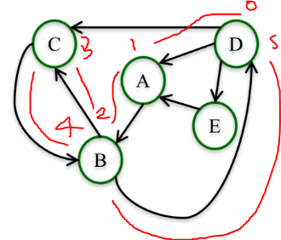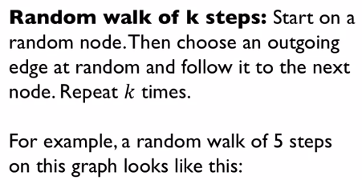

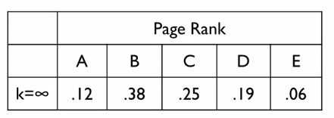

We can interpret the value given from the PageRank as the probability of landing on these nodes after taking infinite number of steps.

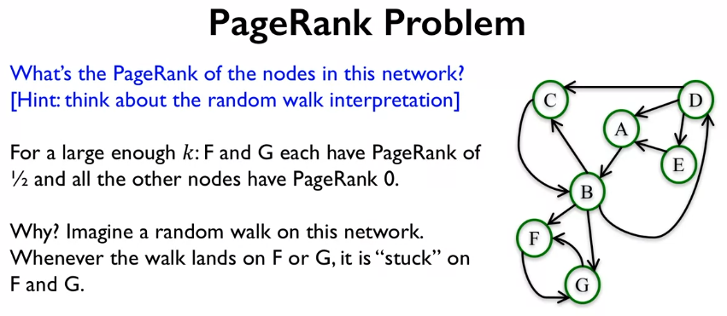

Is fair to say that the nodes F and G are very important, but its note fair that all the other nodes have rank 0. We can fix this problem by adding some damping to the system. The damping parameter α allows us to let the jumps between nodes be on outgoing edges or with the right values jump to a completely random node. This would stop a random walker getting stuck on F and G. normally alpha is chosen between **0.8 and 0.9** so that most of the time its jumping between directed edges, but 1/5 or 1/10 time it jumps to a random node.

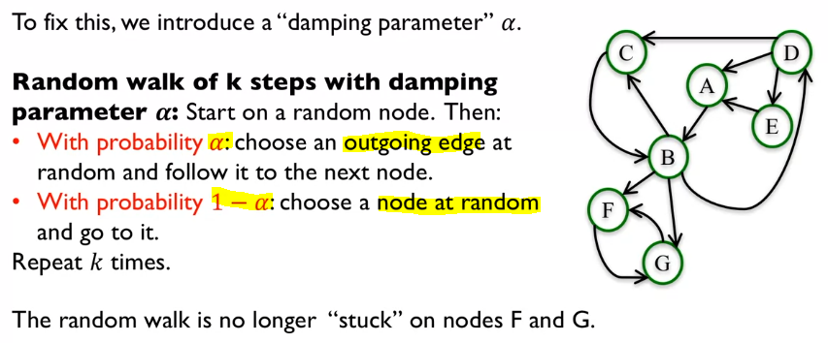

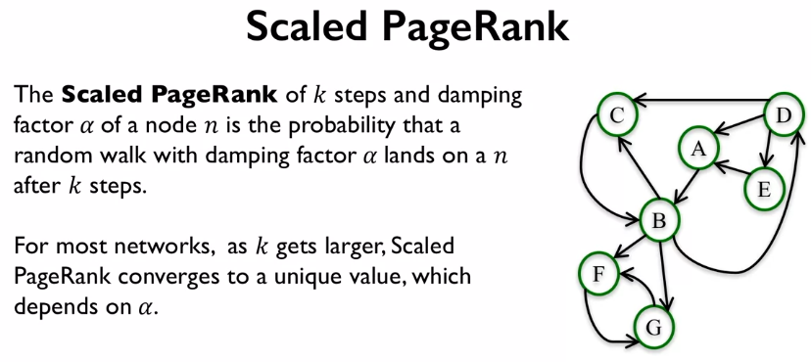

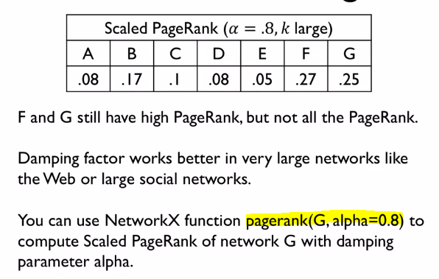

We can see that now the other nodes will have nonzero values. Interestingly, we can see that the order of important pages stays the same. The use of damping parameters performs better when analysing very large networks.

